1. Get your new/additional TJ webmail alias (e.g. [B1-01@tjhsst.edu](mailto:B1-01@tjhsst.edu)) from your teacher. It may be posted on Blackboard.

2. (You may have already done this.) Log in ION with your usual TJ domain (e.g. [2023sstern@tjhsst.edu](mailto:2023sstern@tjhsst.edu)) and set forwarding to your personal email account (e.g. [ninja@gmail.com](mailto:ninja@gmail.com)). You can find the tutorial on the right side bottom.

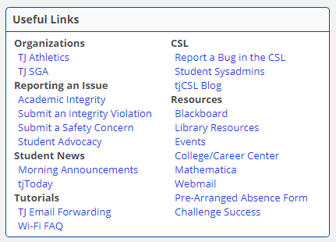

3. Go to CodePost (<https://codepost.io>) and click **Login** button.

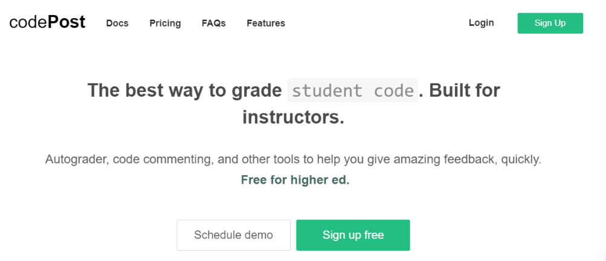

4. Type your email address (e.g. [B1-01@tjhsst.edu](mailto:B1-01@tjhsst.edu)). Then, click Forgot password. You may need to type your email again.

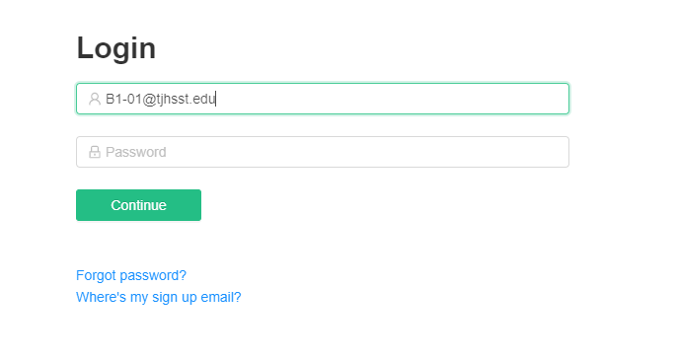

5. Check your personal email (e.g. [ninja@gmail.com](mailto:ninja@gmail.com)) and then reset the password. This may take 20 minutes or longer.

6. Log-in to CodePost (<https://codepost.io>), and then submit Modes and check the feedback.